**Project Design Phase-II**

**Data Flow Diagram & User Stories**

|  |  |
| --- | --- |
| Date | 20 May 2023 |
| Team ID | NM2023TMID02223 |
| Project Name | Industrial Workers Health and Safety System based on Internet of Things |

**Data Flow Diagrams:**

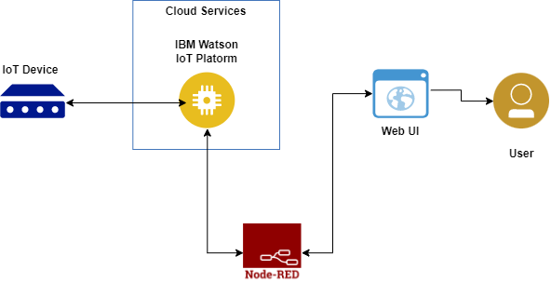

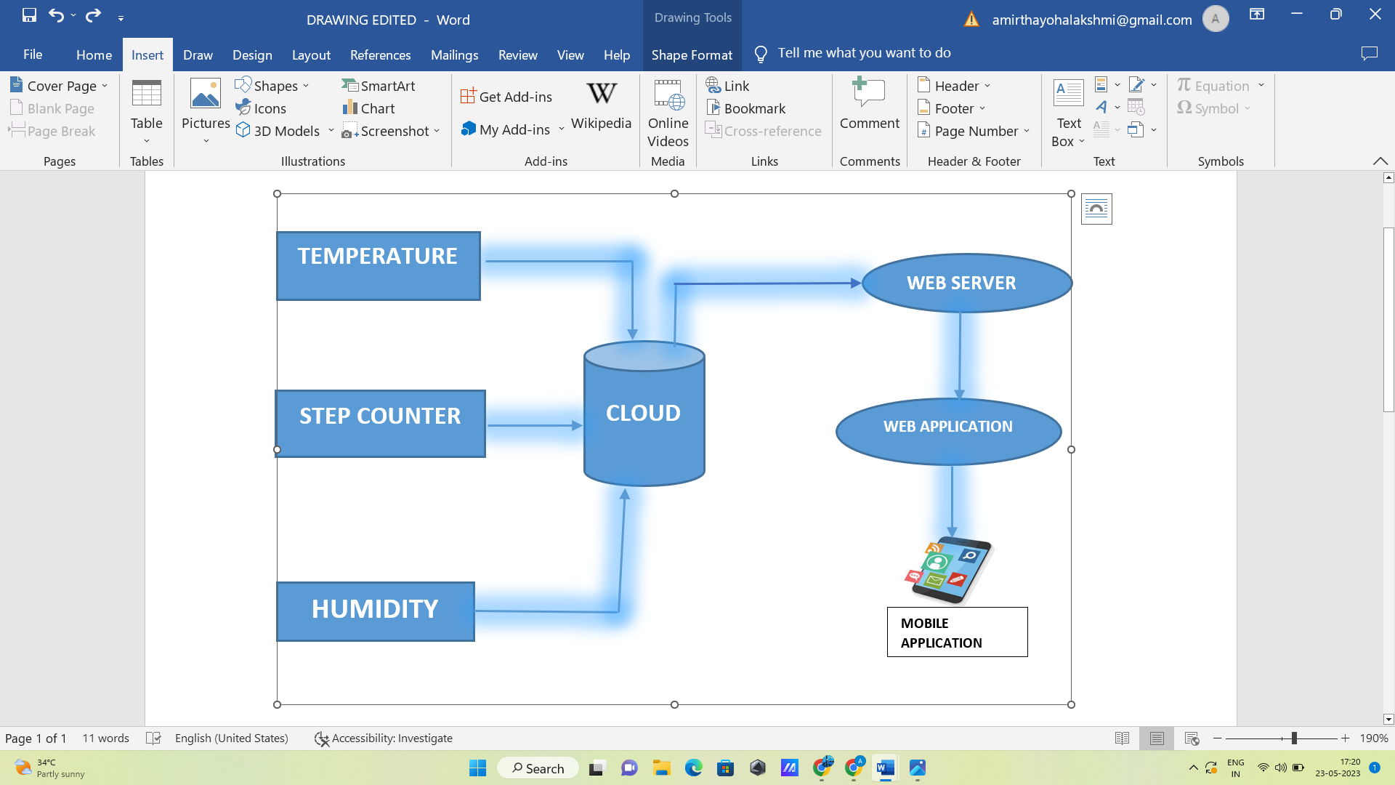

**User Stories**

| **User Type** | **Functional Requirement (Epic)** | **User Story Number** | **User Story / Task** | **Acceptance criteria** | **Priority** | **Team Member** |
| --- | --- | --- | --- | --- | --- | --- |
| supervisor | receive real-time notifications | USN-1 | As a supervisor, I want to receive real-time notifications on my mobile device when a worker enters a hazardous area, so that I can ensure their safety and respond promptly in case of emergencies. | I can to receive real-time notifications on my mobile | High | Vidhya Bharathi |
| worker | connected wearable device | USN-2 | As a worker, I want to wear a connected wearable device that monitors my vital signs, such as heart rate and body temperature, and alerts me if they reach critical levels, ensuring my health and safety on the job. | I can wear a connected wearable device | High | Harshitha |
| safety officer | monitor | USN-3 | As a safety officer, I want to be able to remotely monitor the environmental conditions in the workplace, such as air quality and temperature, using IoT sensors | I can be able to remotely monitor the environment | Low | Harshitha |
| worker | Analyze data | USN-4 | As a manager, I want to analyze historical data collected by IoT sensors to identify trends and patterns in workplace incidents, helping me make informed decisions about safety protocols and training programs to minimize risks. | I can analyze historical data | Medium | Kalai Selvi |
| safety inspector | regular inspections | USN-5 | As a safety inspector, I want to conduct regular inspections using IoT-enabled devices to automatically capture and document safety-related information, reducing manual paperwork and streamlining the inspection process. | I can conduct regular inspections using IoT | High | Vidhya Bharathi |